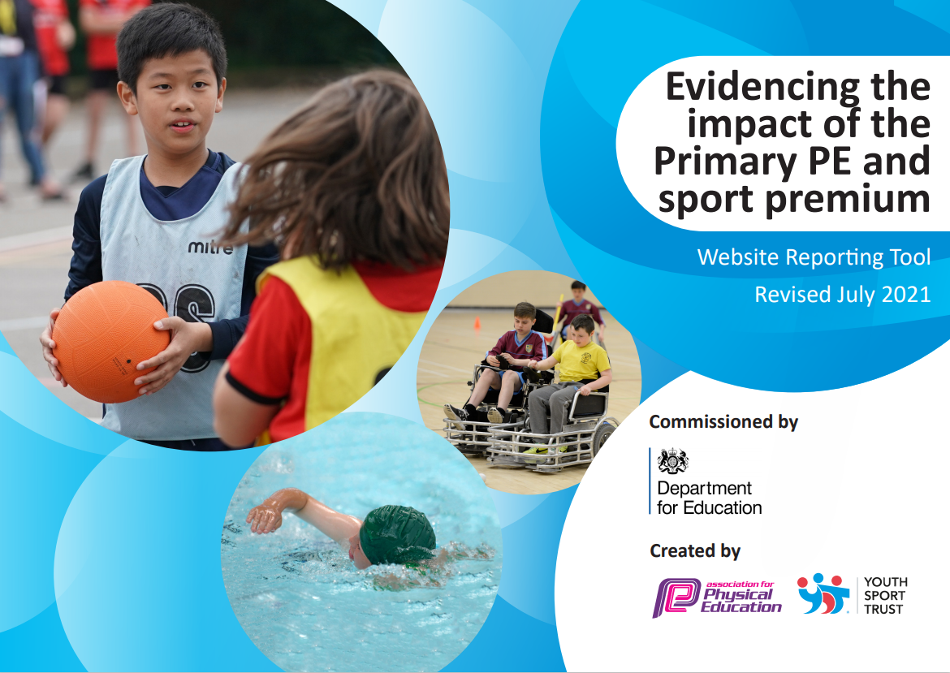

At Willoughby Road Primary Academy, we aim to use the funding in a variety of ways to further improve and develop teaching and learning across the whole academy. Our over-arching vision for our children is to be more active and enjoy sport in all forms. We know that our children do not access enough out of school physical activities and so our funding focuses on improving this within the school day, which in turn we hope, will encourage them to be more active outside of the Academy.

We will encourage pupils to lead healthy lifestyles, enjoy PE and Sport and experience high quality teaching. Every child will be encouraged to take part in competitions and aim for sporting excellence. We participate in all local sporting competitions – some of which are aimed at those looking for sporting challenge and excellence, and some of which are focused on those children who would not put themselves forward and need to develop their sporting confidence.

Having already seen impact of the funding from the previous years we expect for this additional funding to have continued and sustained impact on provision of PE and sport within our academy. Learning walks, lesson observations and monitoring by SLT and the PE leader have identified the following areas to address in PE this year: high quality coaching in KS1 and KS2, increased awareness of healthy lifestyles, increased time of vigorous exercise throughout the school day including lunchtimes. Pupils of all ages and abilities will also have opportunities to participate in competitive events in various locations in the local area. We will raise sporting aspirations of our young people and encourage them to participate in a wide range of sports in and out of the academy.

J. Reid

Details with regard to funding
Please complete the table below.

Total amount carried over from 2019/20 | £9760
Total amount allocated for 2020/21 | £18740
How much (if any) do you intend to carry over from this total fund into 2021/22? | £17136
Total amount allocated for 2021/22 | £18740
Total amount of funding for 2021/22. To be spent and reported on by 31st July 2022. | £35876
Swimming Data
Please report on your Swimming Data below.

Meeting national curriculum requirements for swimming and water safety.

N.B. Complete this section to your best ability. For example you might have practised safe self-rescue techniques on dry land which you can then transfer to the pool when school swimming restarts.
Due to exceptional circumstances priority should be given to ensuring that pupils can perform safe self rescue even if they do not fully meet the first two requirements of the NC programme of study
What percentage of your current Year 6 cohort swim competently, confidently and proficiently over a distance of at least 25 metres?  N.B. Even though your pupils may swim in another year please report on their attainment on leaving primary school at the end of the summer term 2020.  Please see note above | 9%
What percentage of your current Year 6 cohort use a range of strokes effectively [for example, front crawl, backstroke and breaststroke]?  Please see note above | 10%
What percentage of your current Year 6 cohort perform safe self-rescue in different water-based situations? | 44%
Schools can choose to use the Primary PE and sport premium to provide additional provision for swimming but this must be for activity over and above the national curriculum requirements. Have you used it in this way? | Yes/No

Academic Year: 2021 - 2022 | Total Fund Allocated: |  | Date Updated: 11/07/22
Key indicator 1: The engagement of all pupils in regular physical activity – Chief Medical Officers guidelines recommend that primary school pupils undertake at least 30 minutes of physical activity a day in school |  |  |  | Percentage of Total allocation
Intent | Implementation |  | Impact | Sustainability and Next Steps
 |  | Funding Allocated
To encourage children to participate in active brain breaks throughout the day. | Teachers to encourage children to participate in Just dance and Go Noodle sessions every morning when they arrive at school and in middle of sessions during afternoons to encourage them. To get in 30mins of activity daily. | £0 | All children have had opportunity to participate in active sessions. It has allowed children to settle much quicker into their lessons and has a positive impact on their work. | Continue with Go noodle and Just Dance sessions throughout school. Encourage staff to make time during the day to complete them.
To encourage children to lead activities at break and lunchtimes. | Children in Year 5/6 to attend Get Ahead Sports Force Leader training. This will encourage children to keep each other active and run group games at break and lunchtimes. | Included in Get Ahead funding | 8 children attended the training. They were seen to improve games in the playground for other children and taught the children some new games to play. They often lead the games themselves. | Children to be encourage to use skills to pass on their knowledge to other potential sports leaders.  Complete another leader course in the new term.
To encourage children to participate in physical activity during break times. | A range of sports equipment purchased, and storage purchased to set up activity stations at break and lunch times to support children staying active. | £2325 | Children have access to more equipment and break and lunch which has seen the children join in more activities without needing direction. They have also been using bikes and scooters during intervention times. | To show the children how to use the equipment at break and lunch times.  To use the equipment in PE lessons throughout the year.

Key indicator 2: The profile of PESSPA being raised across the school as a tool for whole school improvement |  |  |  | Percentage of Total Allocation
Intent | Implementation |  | Impact | Sustainability and Next Steps
 |  | Funding Allocated
To purchase uniform for PE that children can wear when representing school. | Purchase more clothing that can be worn by KS1 and KS2 children when they attend school events to encourage team spirit and make them proud of representing school. | £2115 | All children have been bought a PE kit for next year PE. Sports kit has been purchased for sport trips, events and competitions. | Children to wear the sports uniform to events to feel like they are part of the team.
To improve outcomes for Year 6 end of KS2 swimming. | Year 5 to attended extra swimming sessions to ensure more reach curriculum goal. | £1727 | More children have reached National Curriculum goal than in previous years and high percentage of children can self rescue. | to enquire about sending more Year 6 children swimming next year to continue this improvement and potentially send a younger year group to be introduced earlier.  Year 4 to complete school swimming next year.
All children to be bought a PE kit for next year | All children to participate in lessons with correct PE kit. | £4578 | All children have been given these PE kits for next year. | All children to wear their PE kit during PE lessons, hopefully encouraging more children to participate and achieving their full potential.

Key indicator 3: Increased confidence, knowledge and skills of all staff in teaching PE and sport |  |  |  | Percentage of Total Allocation
Intent | Implementation |  | Impact | Sustainability and Next Steps
 |  | Funding Allocated
To develop staff’s knowledge of teaching PE with CPD | Staff to attend a zoom training session about how to get the most out of new pe planning tool. PE lead to monitor PE being taught using this programme and to implement extra support if staff require it.  PE lead to attend conferences held by local authority to understand current PE requirements. | £995 (already paid from previous budget) | Staff who can confidently impart knowledge to children and understand requirements for PE.  PE lead able to confidently lead subject and offer support to members of staff when required. | To ensure any staff that may still be finding this tricky are paired with a confident staff member for extra support.
All teachers to teach PE lessons following the staff training. | Teachers to follow and record data on the Primary PE Planning | £395 | All children have successfully joined in a range of PE lessons. Teachers have delivered the lessons confident and this has shown in their improvements. | TO continue to use the Primary PE planning tool to plan lessons to ensure children are receiving a balanced and well taught PE curriculum.
All teaching staff to be bought PE clothing for both PE lessons and extra curricular events. | To improve staffs involvement in PE and feel as if they are part of the event with the children. | £1709 |  | Continue to wear PE kits for teaching PE, ensuring children feel like the teacher is involved in the lesson too.  Enquire about more PE clothing for other members of staff in school.

Key indicator 4: Broader experience of a range of sports and activities offered to all pupils |  |  |  | Percentage of Total Allocation
Intent | Implementation |  | Impact | Sustainability and Next Steps
 |  | Funding Allocated
To encourage children to participate in inspirational activities. | Get Ahead Package Bolt On’s to organise  - Silent Disco  - Get Glowing  - Sports Festival  - Colour run  - Delta Games | £810 | All children have had at least one event they have participated in. Children have enjoyed the events and the children have been extremely motivated to join in more physical activity. | Continue to offer these opportunities through Delta and Get Ahead Partnership.
To encourage children to participate in a range of active after school clubs | Street to Beat dance club hold street dance and cheerleading session 1 of each per week for children to attend from 3:30-4:30pm | £1435 | Some of the children completed the dance competition at the Baths Hall. Children completed a range of dance styles – from street dance to cheerleading. This has raised the profile of dance across school. | Clubs to continue into the new term. Offer a range of dance to all year groups. Compete in the Dance competition again.

Key indicator 5: Increased participation in competitive sport |  |  |  | Percentage of Total Allocation
Intent | Implementation |  | Impact | Sustainability and Next Steps
 |  | Funding Allocated
To attend competitive sporting events run within the Get Ahead partnership | All children across KS1 and KS2 will be given the opportunity to attend a competitive sport morning or day where they will be able to compete against children from other schools.  Transport to events | £2200 (already paid from previous budget)  £4580 | 87% of children across school have participated in a sport morning. Children have become more enthusiastic about sport through these events, and it enthused them for a day of learning. | KS1 and KS2 children to be given the opportunity to participate in the sporting events run by Get Ahead Partnership.
To run competitive sports competitions within school. | Previously purchased activity trackers each class have picked x2 chn wear daily, to see which class can be the most active.  Fun Sports event in house teams where children had to do 12 activities to see which house colour won.  Sports day | Already purchased previous year.  £0 | This has encouraged the children to be more active and want to participate. Enthusiasm about wearing the activity trackers, weekly increase among classes on their data.  Children happy to participate and encouraging team mates. | Plan Sports Day for all year groups.  Encourage children to participate in the tractors activity.

